**RAJ’s Tableau writeups – screen shots---**

**SMU_Proj4_Group1_homicides_TD1**

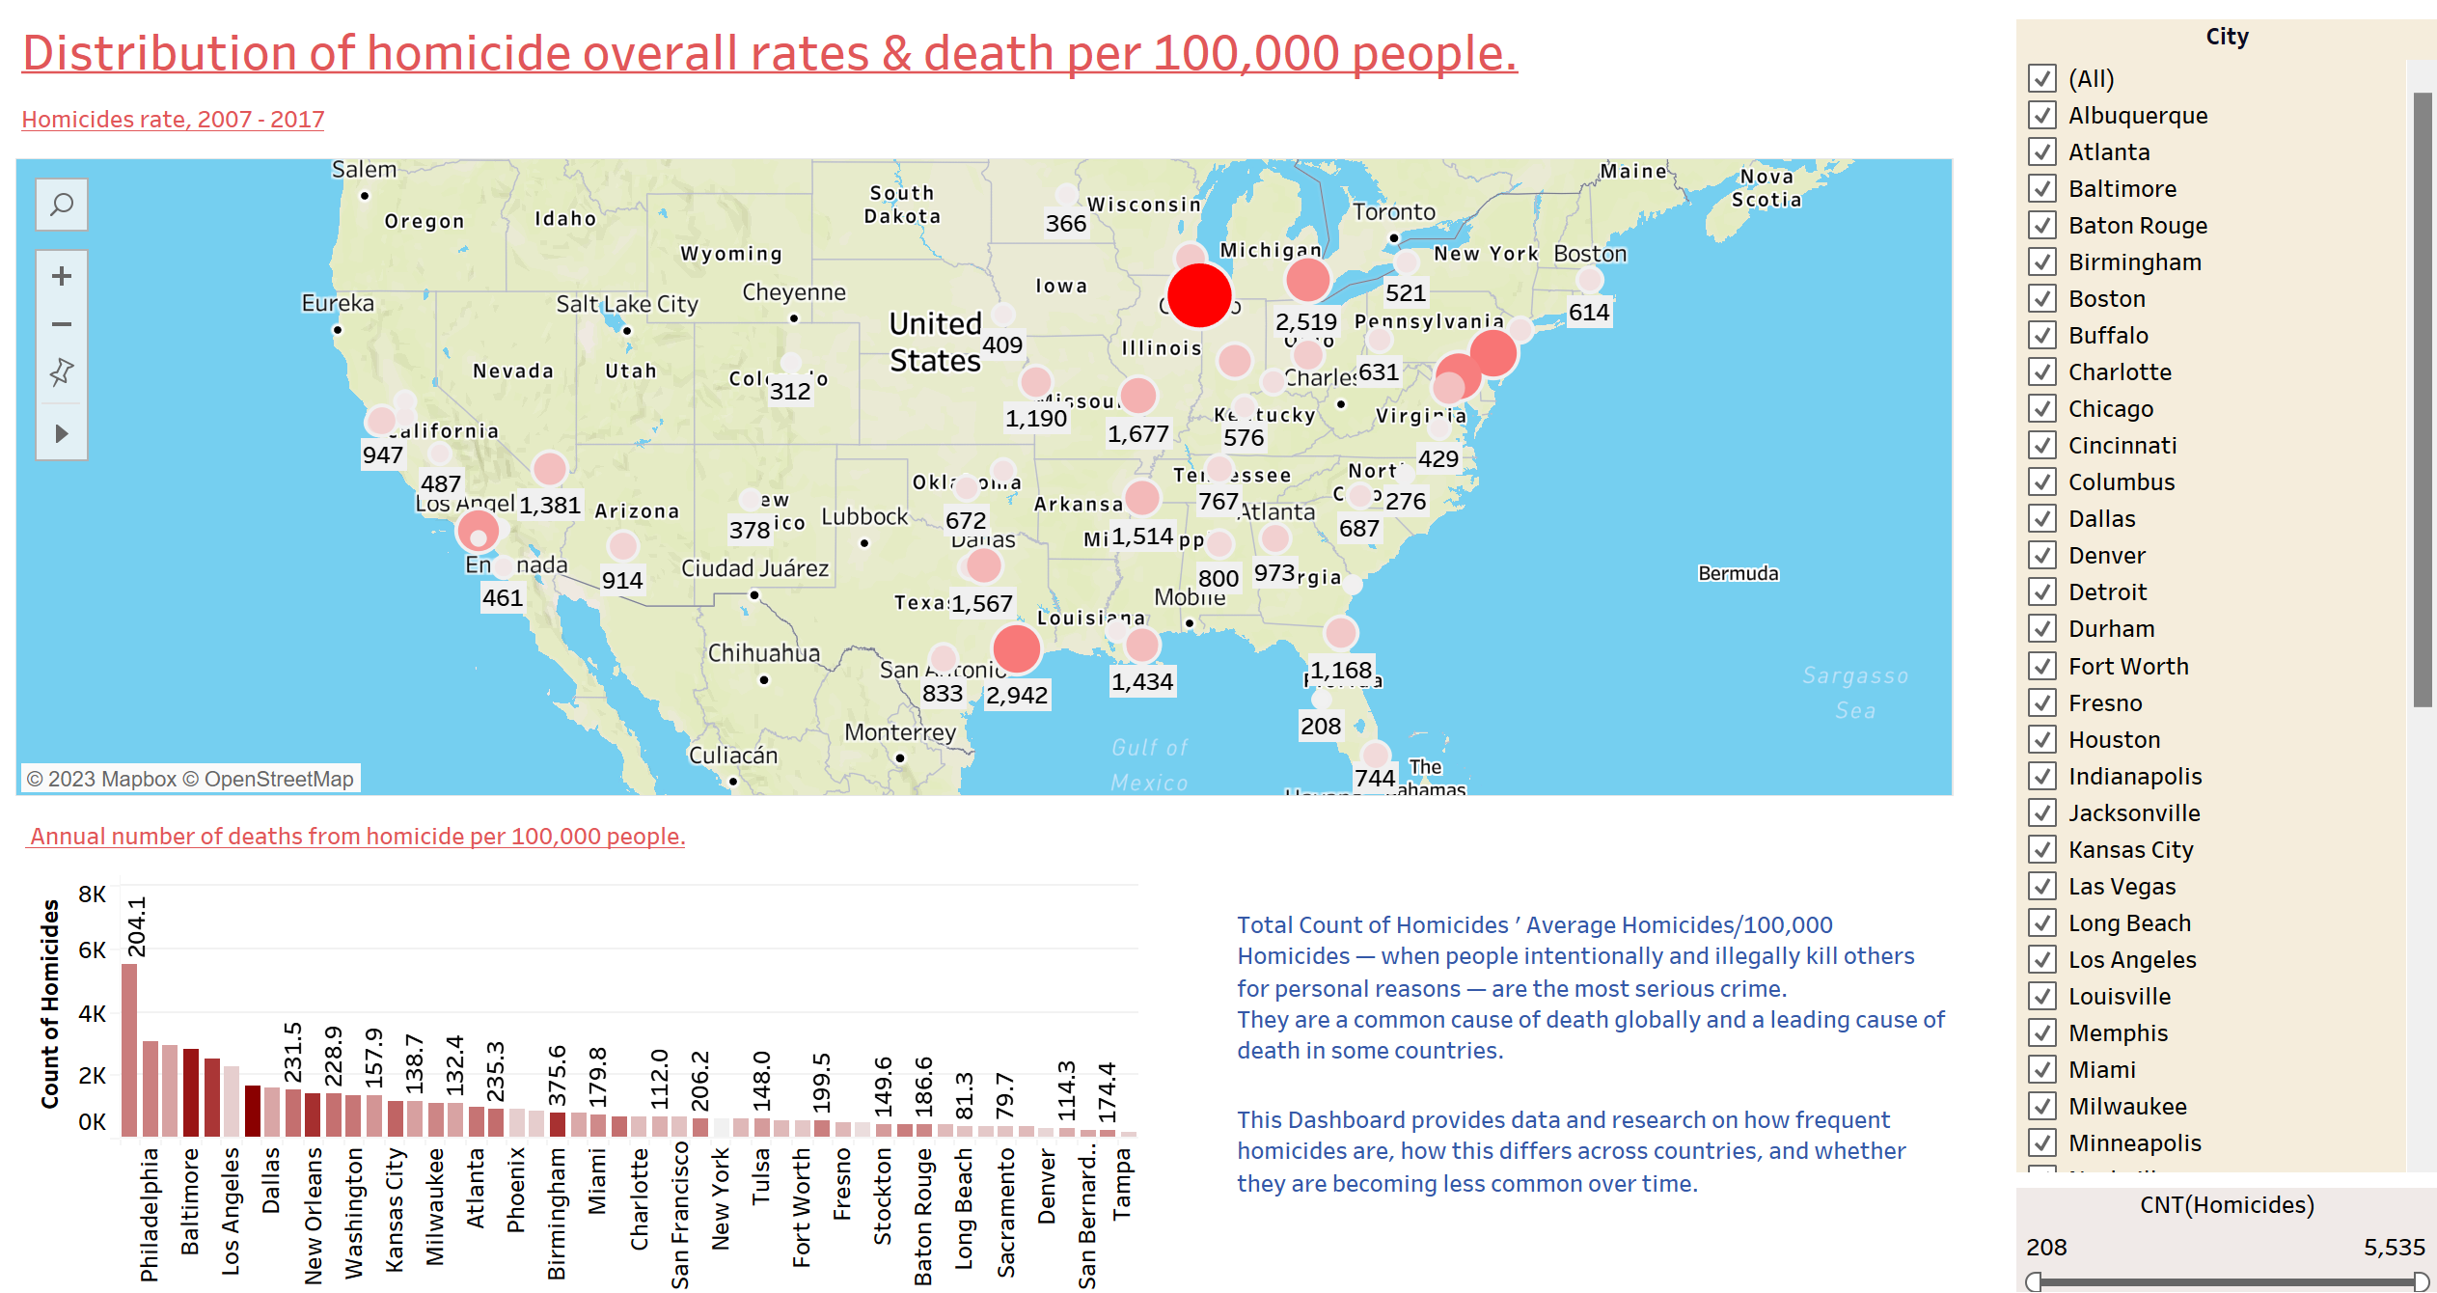

**Tableau dashboard – main page explains about distributions of the homicides across US cities. The dashboard has filters based on Cities & a range of count of homicides**

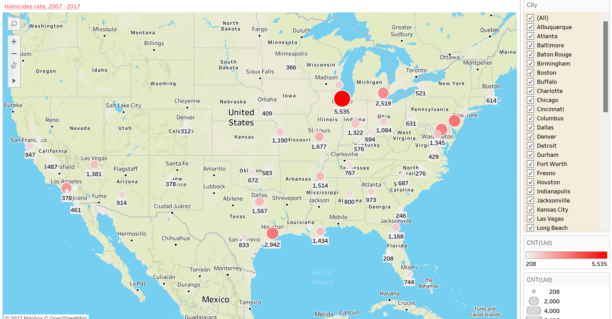

**Tableau workbook – part of dashboard**

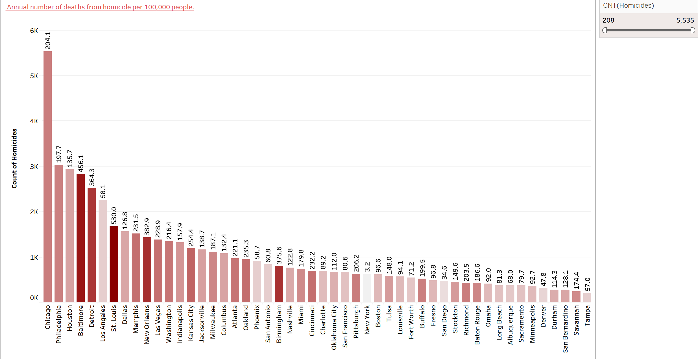

**Tableau workbook – part of dashboard**

**SMU_Proj4_Group1_homicides_TD2**

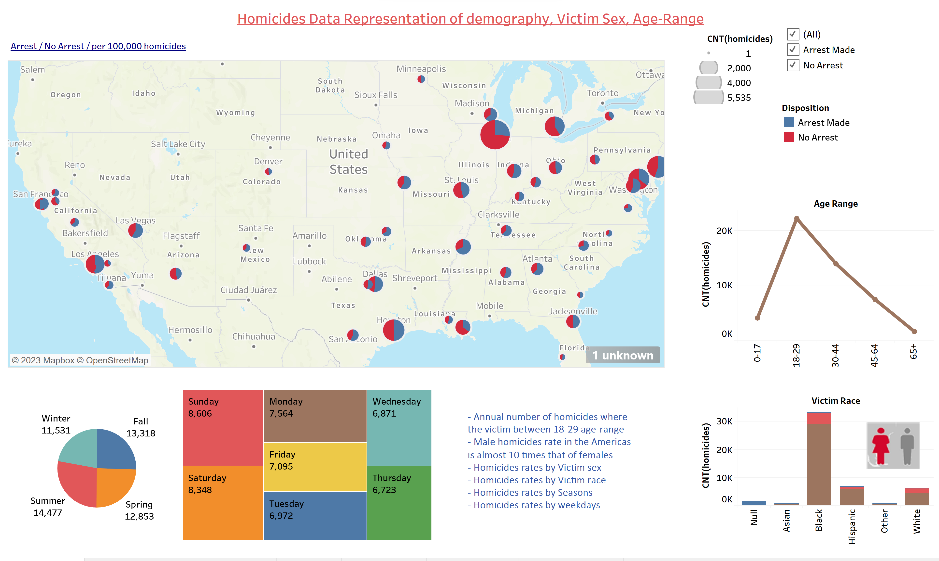

**Tableau dashboard – second page explains demography wise distributions of the homicides across US cities. The dashboard has filters based on “Arrest” “no arrest” & a range of count of homicides**

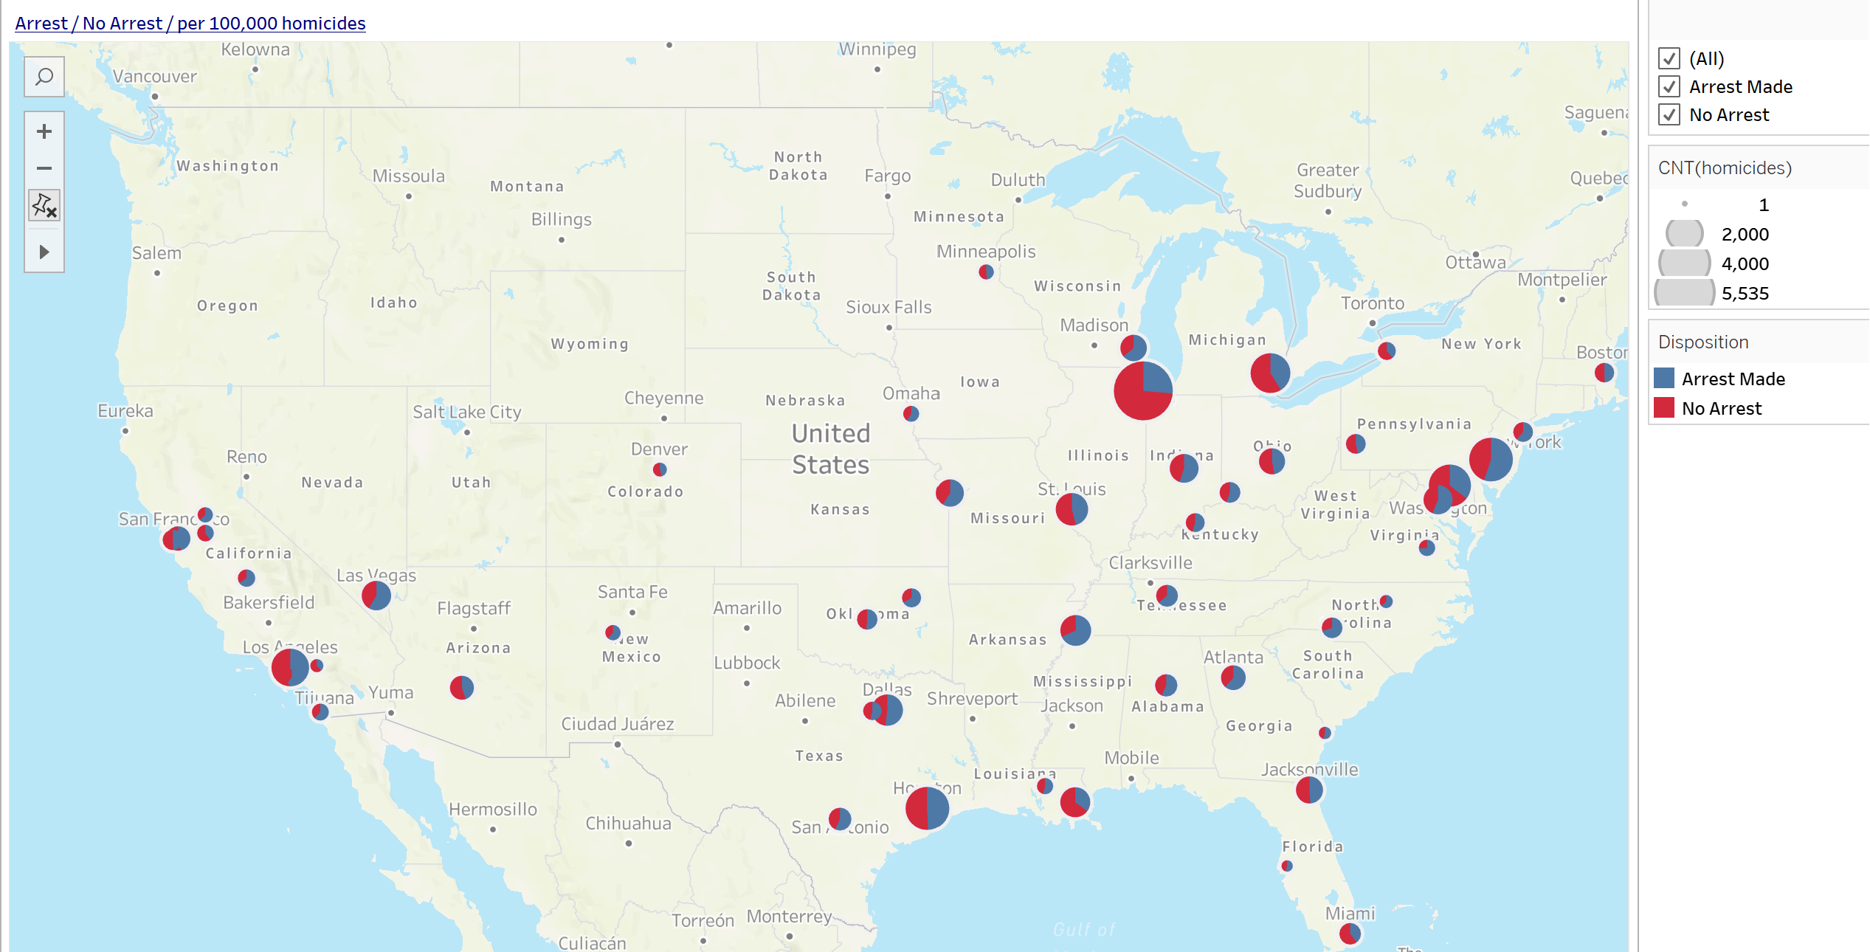

**Tableau workbook – part of dashboard**

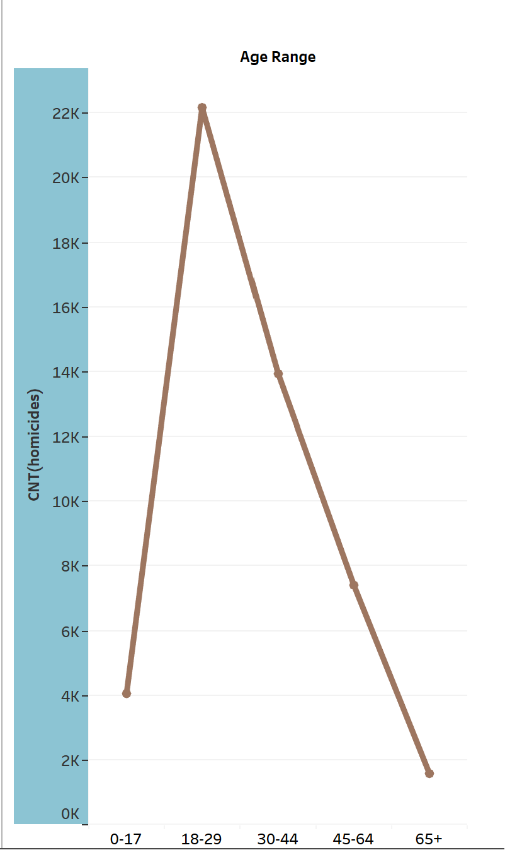

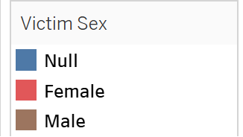

**Tableau workbook – part of dashboard**

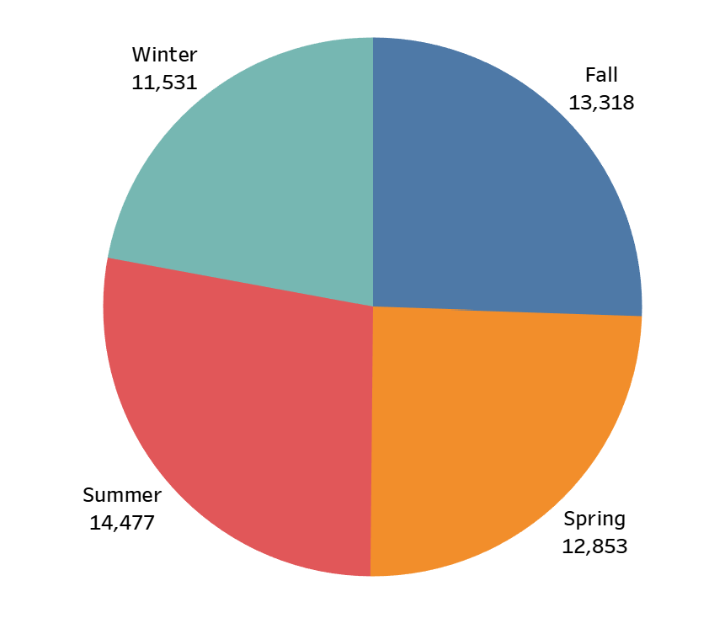

**Tableau workbook – part of dashboard**

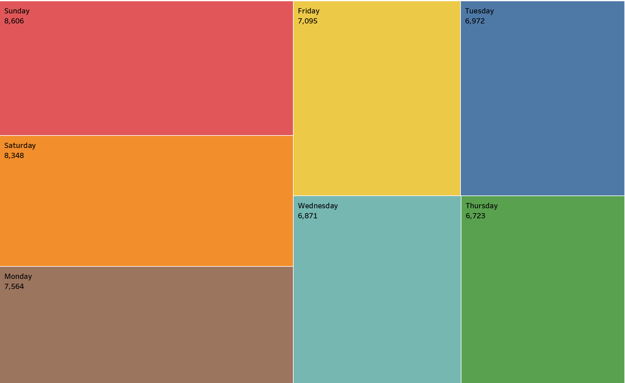

**Tableau workbook – part of dashboard**

**CARLOS – WEBSIDE writeups**

"The development of the homicide website is driven by the goal of offering a valuable online resource for individuals interested in gaining insights into homicide data. This website leverages a dataset spanning the years 2012 to 2017. Some of the highlight and key features and the technologies employed are described. The website's structure adheres to a standard navigation bar while emphasizing two primary features:

The Arrest Prediction Page: This page utilizes data from the years 2012 to 2017 to offer predictive insights regarding arrests related to homicide cases.

Dataset Overview Page: We have dedicated a page to provide an extensive overview of our dataset, incorporating the Ydata library. This dataset overview was originally created within Jupyter Notebooks and subsequently exported as an HTML file.

A dedicated 'Resources' page consolidates various materials that have contributed to the development of the website.

The website itself was constructed using Python and Flask. Its user interface is designed around a straightforward form that prompts users to input data, with clear formatting instructions provided at the top of the form.

The visualization of data is presented on two separate web pages, both developed using Tableau. These Tableau pages, originally designed using Tableau Public, have been integrated into the website through the Tableau API. Providing faster response time than embedding HTML code into the page.

Deployment of the website was accomplished through PythonAnywhere , mirroring the same website structure established during local development. While the deployment process encountered minimal technical challenges, one notable issue arose due to the absence of a required library for the Light GBM (LGBM) machine learning model on the PythonAnywhere platform. As a result, a transition was made to an AdaBoost (ADA) model to ensure functionality.

The website, constructed with Flask, encompasses a total of ten pages. The main page, designed to capture immediate attention, features a dynamic background—a looping video clip. This choice serves to create a visually engaging and thought-provoking backdrop, underscoring the sensitivity of the topic of homicide.

The website's color palette was intentionally selected from Bootswatch's 'Darkly' theme. This choice was made to maintain a tone of seriousness, respecting the gravity of the subject matter—homicide data representation. It underscores our commitment to ensuring that the significance of this data, which represents victims of homicide, is never overshadowed by colors that do not align with the gravity of the topic."